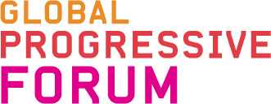
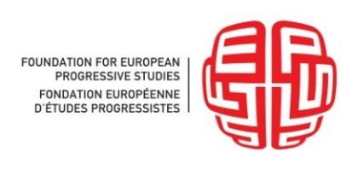
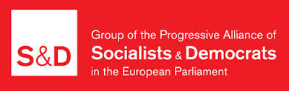
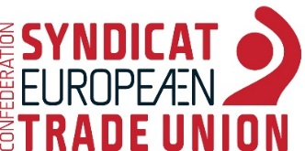
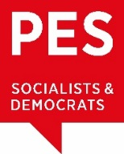

Towards a Progressive Model for Global Partnership and Development
Steering Committee Meeting
European Parliament - Brussels, 6-7 June 2017
This is the first meeting of the Steering Committee on trade and investments. It is the first in a series of three events organised in 2017 as part of the project ‘Towards a Progressive Model for International Trade and Investment’, which is a joint venture between GPF (Global Progressive Forum), S&D (Group of the Progressive Alliance if the Socialists and Democrats), PES (Party of European Socialists), SOLDAR, ETUC (European Trade Union Confederation) and FEPS (Foundation for European Progressive Studies, Brussels). A second meeting of the Steering Committee is envisaged for October 16-17, 2017 in Washington, D.C. The last meeting for this year will be hold in Brussels, in November. The aim of the project is to promote a regime of international trade and investment properly governed and oriented towards more fairness, equality and progressive changes, meeting the ambitious sustainable development goals as defined in the Agenda 2030. The discussion will feed into final common policy proposal (finalized by mid-2018). A researcher employed to accompany the project will assist the members of the steering committee with the writing and editing process.
Today’s meeting will proceed as follows: The ice-breaking session will introduce all participants to the methodology of the meeting. During the sessions, discussants will have 10 minutes each to present their respective viewpoints. The floor will then be opened to all participants for debate.

Draft Agenda

8:40 Welcome and accreditation - Meeting point: Altiero Spinelli Building entrance

Room: A7F387 from 9:00 to 17:30

9:00 Ice-breaking session: methodology and goals of the project

Opening remarks by Enrique Guerrero Salom MEP, GPF President, on behalf of the project partners

9:15 Q&A and remarks by SC members

***
10:30 Coffee break

***

11:00 1st session: Is there a Left approach to globalization and trade?
Globalization and trade negotiations have provoked a heated debate in many countries over the past few years. These debates have been particularly long and substantive within the progressive camp. Some of the most critical sources of resistance to globalization and free trade agreements, often negotiated by progressive leaders, were left-wing groups, labour unions, NGOs and social movements. Why these issues are so divisive for the Left? What should be the fundamental pillars of a progressive approach to globalization and trade? How can progressive policymakers encourage further global partnerships and economic integration? How can we ensure transparency and ensure an appropriate level of civil and social dialogue? How can we ensure equal opportunities for stakeholders to help shape trade agreements and avoid any preferential treatment of privileged access to negotiations?
Discussants (10’ each): Pascal Lamy
Paul Magnette

11:20 Debate

***
12:30 Lunch - MEP’s Restaurant - Salon....
With welcome adresses by Gianni Pittella MEP, S&D Group leader, Sergei Stanishev MEP, PES President, Massimo D’Alema, FEPS President, Conny Reuter, Solidar Secretary general, Rudy De Leeuw, ETUC President
***

14:00 2nd session: Trade governance and growth: challenges and perspectives
What is the role of trade agreement in promoting growth? How can trade be used as an effective tool to support emerging economies in developing countries? How can industrial policy enable citizens to benefit from international trade? How can we ensure coherence between internal and external policies? How can all levels of governance - local, national, international - be constructively involved in the decision-making process of trade agreements?

Discussants (10’ each): Eveline Herfkens
Stephany Griffith-Jones
Jean-Luc Demarty, Director-General DG Trade (TBC)

14:30 Debate
***

15:30 Coffee break
***

15:45 3rd session: Sustainable development and equality
How can international trade and social objectives be bound together more effectively? How can the benefits be more equally shared? Which domestic flanking measures are needed in order to boost a ‘quality job-rich’ and sustainable growth and ensure a fair distribution of wealth for the people, notably for those worst off, as well as an improvement in their living standards? How can trade policy ensure that the benefits of global value chains are fairly distributed among producers, consumers and jobholders? Furthermore, how can trade be used as an effective tool to support industrial development and economic growth in developing countries?
Discussants (10’ each): Linda McAvan
Laura Sullivan, Regional Director for Europe and the Americas Action Aid International – CONCORD Europe Vice-president

16:05 Debate

17:15 Closing remarks by Enrique Guerrero

17:30 End of 1st day of meeting

20:00 Informal dinner – Restaurant

***

8:45 Meeting point: Altiero Spinelli Building entrance

Room: A1E1 from 9:00 to 13:00

9:00 Opening remarks by SC chair Poul Nyrup Rasmussen

9:15 4th session: Investments, public services and dispute regulation
How do we strike the right balance between protecting and facilitating investment to stimulate sustainable growth and decent job creation on the one hand and safeguarding states’ rights to regulate in the public interest on the other? How can we protect public and social services and the right to regulate in areas of public services? What are the pillars / benchmarks, guiding principles of a global procurement market that the EU want to promote? Which sectors should be included and which not? And how hot organise the exclusion aspect, through positive or negative listings? How can any particularly troubling features of investment protection provisions inserted in trade agreements be avoided?

Discussants (10‘ each): Nathalie Bernasconi
Bernd Lange

9:35 Debate

***
10:45 coffee break

***
11:00 5th session: Social justice and social dumping
How can the potential of international trade be borne, while promoting and protecting human rights, labour rights, fundamental freedoms, consumer protection, cultural diversity and environmental standards when it comes to negotiating political and economic agreements? How can one ensure that the development of international trade will further strengthen, and not hinder, achievements in these areas? In what ways can social dumping be avoided? Are existing tools sufficient to address unfair competition from third countries? How to make clear that violations of economic, social and cultural rights as well as labour standards, combined with erosions of social protection provisions and reduction of entitlements, have an unfair impact on trade? How to integrate the enforceability aspect in this regards in trade agreements? How do we account for widespread opposition to new international investment agreements, while pressing for comprehensive reform of the already existing, fragmented system of thousands of treaties worldwide that have established non-transparent, corporate-friendly private arbitration?

Discussants (10’ each): Carles Casajuana
Alessia Mosca
Liina Carr, ETUC Confederal Secretary

11:30 Debate

12:30 Closing remarks by Enrique Guerrero

***
13:00 Lunch and end of meeting

